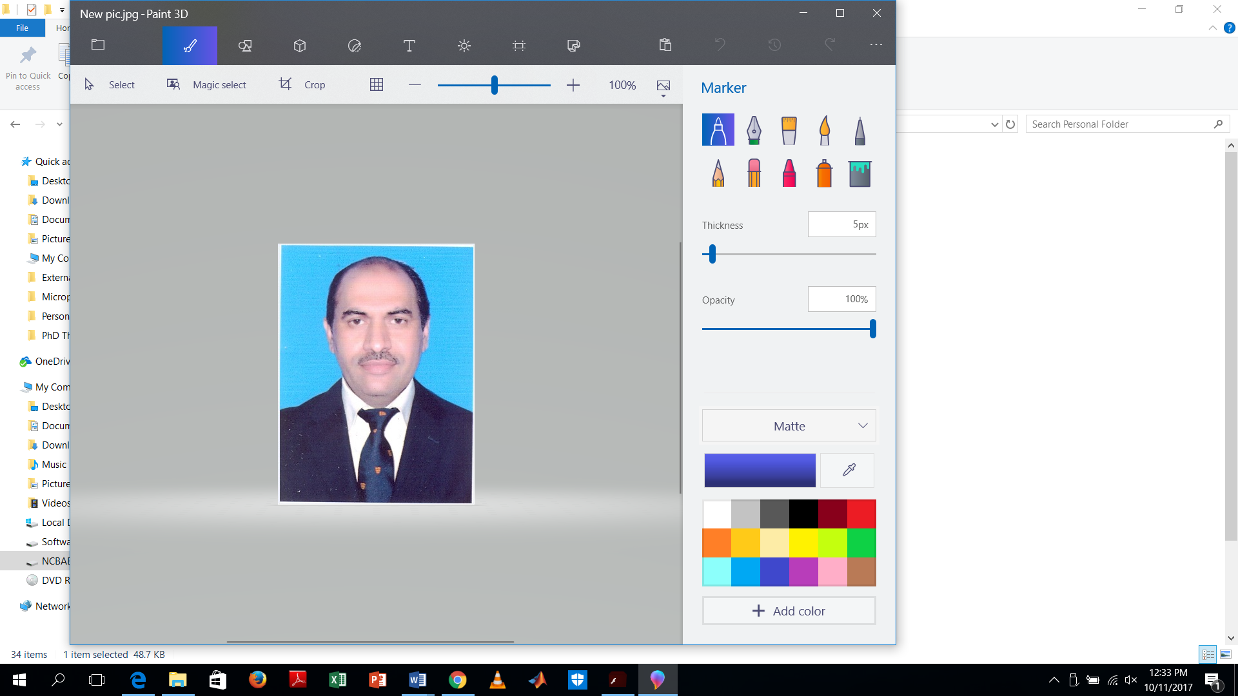
Dr. SHAHID NASEEM
Assistant Professor (IT)
Department of Information Sciences, Division of
Science & Technology, University of Education,
Lahore, Pakistan. Cell: +92-300-5305627
Shahid.naseem@ue.edu.pk CNIC: 35202-2379575-5
________________________________________________________

Research Interests:
Studied and dignified computer science Assistant professor (CS&IT) with established following and thorough discipline in the practice of Artificial Intelligence programming, looking for new academic opportunities. Have been involved in the development and launch of pioneering research and interdisciplinary programs for students.
Education:
2014~2017: Ph.D (Computer Science)
National College of Business Administration & Economics, Lahore.
Research Topic: Self-Organizing Information Protection in Memory using Cognitive Correlates
2011~2014: M.Phil (Computer Science)
National College of Business Administration & Economics, Lahore.
Research Topic: Web Application Interoperability: Semantic Inference using Dynamic Ontologies
2002~2004: MCS
College of Global Technology, Rawalpindi Affiliated with Al-Khair University, AJK.
Project Topic: Statistical Information System for Werrick Pharmaceutical

1993~1995: B.Sc (Double Math, Physics)
Punjab University, Lahore.

1990~1992: F.Sc (Pre-Engineering)
Board of Intermediate and Secondary Education, Lahore.
1988~1990: Matric (Science)
Board of Intermediate and Secondary Education, Lahore.
Work Experience:

Teaching Experience:
Oct, 2018~ till date Department of Information Technology, Division of Science & Technology, University of Education
Title: Assistant Professor (IT) on Track Tenure System

Jan, 2018~Oct, 2018 Department of Computer Sciences, University of Sargodha, Lahore Campus, Lahore.
Title: Assistant Professor (IT)

Sep, 2017~ Dec, 2017 Department of Computer Sciences, Bahauddin Zakariya University, Lahore Campus, Lahore
Title: Assistant Professor (IT)

2012~2017 Department of Humanities and Social Sciences, University College of Engineering, Sciences & Technology, Lahore Leads University, Lahore
Title: Assistant Professor (IT)

2011~2012 Department of Civil Engineering, University of Lahore, Lahore
Title: IT-Lecturer

2007~2011 O/O Chief Engineer (Power), Punjab Irrigation & Power Dept.
Title: System Analyst (BS-17)

2002~2007 National Highway Authority, Islamabad
Title: Computer Operator

Jan,2002~ Sep,2002 Bridge Computers
Title: Asstt. System Engineer

Visiting Faculty:

2005~2006 Pakistan Manpower Institute, Islamabad
Title: Database Instructor

2009 Punjab Government Engineering Academy, Lahore
Title: Instructor

2014~till date Department of Computer Sciences, ILM/UMT Campus, Lahore
Title: Part-time Lecturer

2016~2017 Department of Computer Sciences, National College of Business Administration & Economics, Lahore
Title: Part-time Lecturer

Non-teaching Experience:
2007~2011 Department of Chief Engineer Power, Punjab Irrigation & Power Department, Lahore
Title: System Analyst (BS-17)

2002~2007 Department of Computer Bureau, National Highway Authority, Islamabad
Title: Computer Operator

2002~2002 Bridge Computers, Lahore
Title: Asstt. System Engineer

1996~2001 Mishal Saniya (Pvt.) Ltd, Lahore
Title: Network Administrator

Honor/Awards:

2004 Get best instructor award from Chairman NHA, Islamabad, Maj. Gen. Farrukh Javed.
Projects:

2003~2004 Employee Training System (ETS) for maintaining the record of NHA employee’s, training material, employee’s results.

2009~2010 Electricity Billing Monitoring System (EBMS) for analysing the billing data of 176 Government/Semi-Government/Autonomous Bodies.

Training Courses:

2002 Computer Hardware certification, Brain College, Lahore.
2003 MCSE certification, Global College, Islamabad.
2003 CCNA certification for router configuration, Corvit, Islamabad.
2004 Linux System Administration certification, Pakistan Computer Bureau, Islamabad.
2006 Computer & Internet Securities, Pakistan Institute of Management, Lahore.
2006 Java Script Programming certification, Pakistan Computer Bureau, Islamabad.
2006 SQL Server 2000 certification, Pakistan Computer Bureau, Islamabad.
2008 Computer Fundamental (CS-254) certification, NCSA, Denmark.
2010 SQL (CP-207) certification, NCSA, Denmark.
2010 Java Script (CP-420), NCSA, Demark.
2012 Web designing using CSS, ASP and PHP tools, Nets College, Lahore.
2020 Two-days (Jan 4-5, 2020) training on “Promotion of Peace” at UE, Township, Lahore.

Publications:
Journal Articles:

- “Cloud Computing and e-Governance” ISSN 2229-5518”, IJSER (4.2) Volume 3, Issue 8 August, 2012.
- “Neural Network Intrusion Detection Architecture for Distributed System ISSN 2229-5518”, IJSER Volume 3, Issue 8 August, 2012.
- “Usage & Issues of Cloud Computing Techniques in Small and Medium Business Organizations ISSN 2229-5518”, IJSER Volume 3, Issue 5 May, 2012.
- Intrusion Detection Architecture for Distributed Systems using Game Theory Approach, ACEEE, ISSN 797-9617”, Volume 2, Issue 2, February, 2014.

- Intrusion Detection and Prevention in Cloud Computing using Genetic Algorithm, IJSER, vol.5, Issue.12, 2014.
- “Learning-Based Routing in Cognitive Networks” published in IJSER, Vol.5, Issue.12, and December, 2014.
- “Cognitive System for Objects Serving in Industry” published in IISTE (Computer Engineering and Intelligent System), ISSN 2222-1697, Vol.6, Issue.1, January, 2015.
- “DNA Analysis using Finite Automata” Published in IRJCS (International Research Journal of Computer Sciences), Vol. 1, Issue 2, October, 2014.
- “Hibernation Mechanism in Smart Phone Mobile” published in IISTE (Journal of Energy Technologies and Policy, Vol.5, Issue.1, January, 2015.
- “Forecasting of Intellectual Capital by measuring innovation using Adaptive Neuro-Fuzzy Inference System”, International Research of Applied Sciences. ISSN: 2411-667X, Vol. 2, No. 1, 2015.
- “Genetic Algorithm & Fuzzy Logic Based PEM Fuel Cells Power Conversion System for AC Integration”, International Research of Applied Sciences, Vol 2, issue 2, 2015.
- “Graphical User Interface of Fuzzy Logic Based Distributed Flood Adaptive Control System for Agricultural Land and Power Generation in Punjab, Pakistan”, Pakistan Journal of Sciences (HEC ‘X’ Category journal, Vol. 68 No. 1 March, 2016).
- “Adaptive Optimizing Virtual Machine for Memory Management”, IJSER, Vol.7, Issue.5, May-2016.
- “Memory Management by Inter-positioning the Balloon Mechanism in Virtualization”, IJSER, Vol.7, Issue.6, 2016.
- “Natural User Input Management (NUIM) Through Computer Architecture and Operating System in Virtual Reality”, Asian Journal of Social Sciences and Management Studies, vol.3, Issue.4, 2016.
- “Information Protection in Cognitive Science”, IJCSNS, Vol.17, Issue.3, March-2017.
- “Enhancing Cloud Security using VKC as a Service”, IJCSNS, Vol 17, Issue.6, June-2017.
- “Self-Enabling Vehicular Agent using Cloud and Massive Data”, LGURJCSIT, Vol.1, Issue.2, 2017.
- “Information Protection - A Comparative Analysis of Popular Models”, IJCDS, Vol.1, Issue.7, 2018.

Book & Book Chapters:

- “Web Application Interoperability” book published in Germany through “Lambert Publisher ” on 29.3.2016 and available on www.amazon.com
- “Habit Development Framework for Rational Behaviour Generation in Agency” published in Germany through “Lambert Publisher” on 8.7.2016.
- “Autonomous Statistical Information System for WERRICK Pharmaceuticals” published in Germany on 1.10.2016 through Lambert Publisher

Conference Papers:

- Participated in the 2nd International Conference, held at University of Management Technology, dated 28-29 March, 2012 as “presenter” and presents my paper regarding “Computerize Monitoring of Noise & Dust level at road crossings of Lahore”.
- “Quantum Learning for Semantic Inference using Dynamic Ontology”, presented in 1st Doctoral Conference at UMT, December 07, 2013.
- “Dynamic Ontologies Evaluation Framework using Quantum Perceptron Neural Network”, presented in 9th ICOSST 2015 at UET, Lahore, December 17-19, 2015.
- “Self-Differentiating Real-time and Synthetic Voices System”
, presented in 1st International Conference of Indigenous Resource Management: Challenges & Opportunities, UMSIT, Kotli, AJK, April 14-16, 2016.
- “Strengthening the Security of Cognitive Packet Networks by Using RNN”, presented in 1st National Conference of Computer Science and Information Technology 3-4, May,2017 at Lahore Garrison University, Lahore.
- “Pakistan International Airline Revenue Optimization using Dynamic Programming for Yield Management”, in 2nd National Conference of Computer Science and Information Technology, 28-29 March, 2018 at Lahore Garrison University, Lahore, Pakistan.
- “Linear Classification of Traumatic Brain Injury using Perceptron Neural Network”, 1st International Conference held at Lahore Garrison University, December 19-20, 2018.
- “Quantum Cognitive Intrusion Detection Biometric System: a case study in Fingerprints”, 1st International Conference on Science, Technology and Innovation, at Kinnaird College for Women, Lahore, April 2-4, 2019.
- “Prospects and Development of E-learning and E-leadership”, 7th International Conference of Education at Division of Education, University of Education, Lahore, April 10-11, 2919.
- “Invited Speaker” at 2nd International Conference on Computer Science and Allied Technology, LGU, Lahore, November 27-28.2019.
Reviewer:
- Elsevier Journal since 2014
- International Journal of Computer Sciences & IT, Lahore Garrison University since 2016.
- Bahira University, Lahore Campus since 2017.
- EDAS, Bahrain since 2017.
- Technical Program Committee Member for The 2019 IEEE Middle East and North Africa Communications Conference (MENACOMM 2019) (IEEE MENACOMM'19), (http://www.menacomm2019.org)
Workshops:

- “Official Procedures and Practices” held at National Highway Authority under Secretariat, Islamabad, June 13-July 8,2003.
- “Computer Training of Focal Persons for Monitoring of Energy Billing of Punjab Government Depts” held at Government Engineering Academy, Punjab, Lahore, July 27-29, 2009.
- “Teacher Development Program” workshop held at UCEST, Lahore Leads University, February 21, 2015.
- “Risk Assessment and Management” held at UCEST, Lahore Leads University under Pakistan Engineering Council, March 02,2015.
- “Inspirational Teaching” held at UCEST, Lahore Leads University, Lahore, January 23, 2017.
- “Strategic Planning for your organization” held at Division of Education, University of Education, Lahore, April 23,2019.
- “Transdisciplinary Research” held at UMT, Lahore, July 17-18,2019.
Personal Information:
House No.8, Street No.4, Block-Y, Wassanpura, Scheme No.2, Lahore, Pakistan
D.O.B: December 15, 1974
Passport No: AP9855751
Domicile: Lahore, Pakistan

Membership:
- Youth Parliament PB-LA-0000131 15.04.2008
- UOL-SAFE (Students Aim to Flourish Environment) 10.05. 2012
- International Engineering & Technology Institute, Hong Kong 12.1.2018

